**FAITH LUTHERAN CHURCH**

## **The Second Sunday after the Epiphany**

**January 19, 2024**

**Rev.** **Patrick Poock**

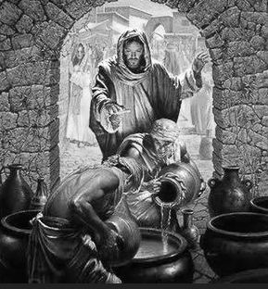

***The Divine Glory Is Manifested in the Signs of Christ***

When Jesus turned water into wine at the wedding in Cana, it was “the first of his signs” by which He “manifested his glory” (John 2:11). It pointed to His coming “hour,” when He was lifted up on the cross for the forgiveness of sins and the life of the world (John 2:4; 12:23–32). The glory of the cross is incomprehensible apart from the Word and Spirit of God, but disciples of Jesus recognize that glory in the signs of His Gospel, and so they believe in Him. Jesus does not wait for His disciples to discover Him on their own, but He seeks out the forsaken and the desolate and unites them to Himself. He adorns them with His own beautiful righteousness and delights in them “as the bridegroom rejoices over the bride” (Is. 62:4–5). Purified by the washing of water with His Word in Holy Baptism, His disciples confess that “Jesus is Lord,” and they return thanks to Him “in the Holy Spirit” (1 Cor. 12:3) as they drink the good wine that He pours out for them, which is the new testament in His blood.

**THE DIVINE SERVICE** is celebrated each **Sunday** at **8:00 am** and **10:30** **am** and **Wednesday** at **5:00 pm**. **Bible Class** is held on **Sunday** at **9:15 am** and **Wednesday** at **3:30 pm** and **6:30 pm**.

**FAITH LUTHERAN CHURCH** is a Christological, Scriptural, Confessional and Liturgical member of the Lutheran Church-Missouri Synod. We believe that God has called us to believe, teach and confess that Christ was crucified for our sins and we receive salvation by faith, which is a gift of God through His grace given to us in our baptism, as is revealed in the Holy Bible which is the inspired and inerrant Word of God. In response to His gift of salvation we eagerly desire to do good works out of thanksgiving and praise to the Triune God.

**COMMUNION STATEMENT**

Because we take the Word of God seriously and we love our visitors, **we ask that if you are not a member of Faith Lutheran or another LCMS church, please refrain from taking communion until you have talked with Pastor Poock.** In the meantime, we would love to have you participate by coming forward and receiving a blessing.

Communion offers the immense blessing of forgiveness of our sins. However, it can be taken to one’s judgment if not properly understood. 1 Cor 11:27,29 says, “Whoever, therefore, eats the bread or drinks the cup of the LORD in an unworthy manner will be guilty concerning the body and blood of the LORD…For anyone who eats and drinks without discerning the body eats and drinks judgment on himself.”

We teach that a person receives the real Body and the real Blood of Jesus Christ “in, with and under the bread and wine.” It is not symbolic or merely a spiritual presence.

**WELCOME TO OUR VISITORS!**

We rejoice to have you with us today. The liturgy is found in the Lutheran Service Book in the rack in front of you. You may place this bulletin in the back of your hymnal to help you follow along with the order of service. The Propers for the day are printed within the bulletin. Please read the message in this bulletin concerning reception of Holy Communion at our church.

The first quarter of 2025 is designated by Pastor and the Elders for **Our Daily Bread of Bradenton**. The mission of Our Daily Bread is to provide for the nutritional needs of the poor and needy of our community in the context of compassion and affirmation of their human worth as Children of God. They achieve this by providing a daily soup kitchen and food pantry. Please note “Missions” on your donation check. Thank you for your generosity in supporting God’s work.

**Weekly Memory Verse Colossians 2:8–9**

See to it that no one takes you captive by philosophy and empty deceit, according to human tradition, according to the elemental spirits of the world, and not according to Christ. For in him the whole fullness of deity dwells bodily.

408 COME, JOIN IN CANA’S FEAST

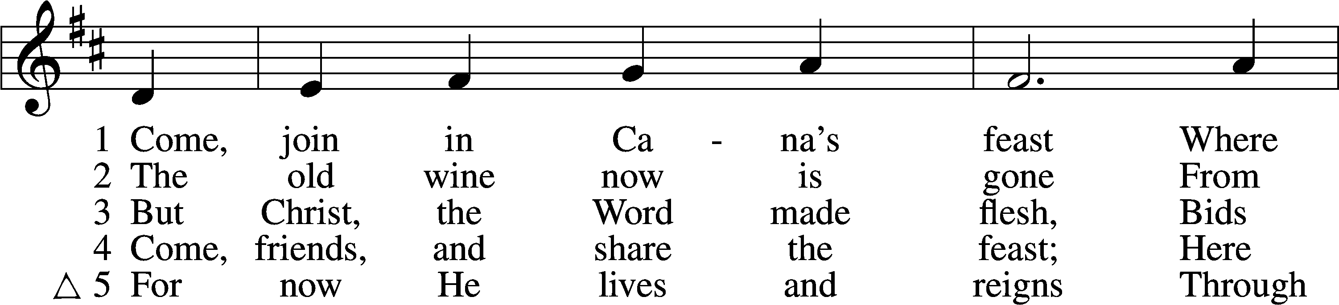

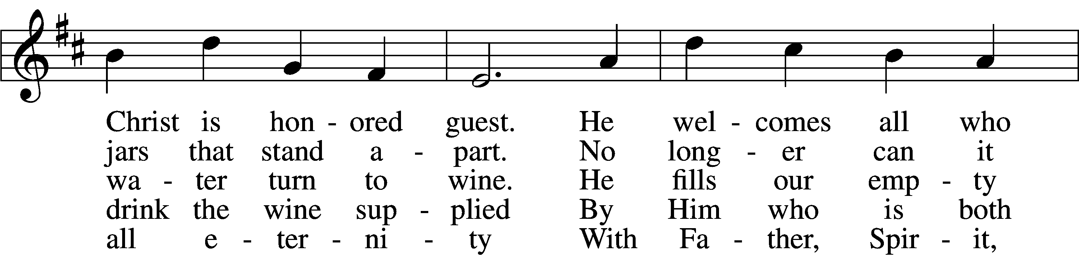

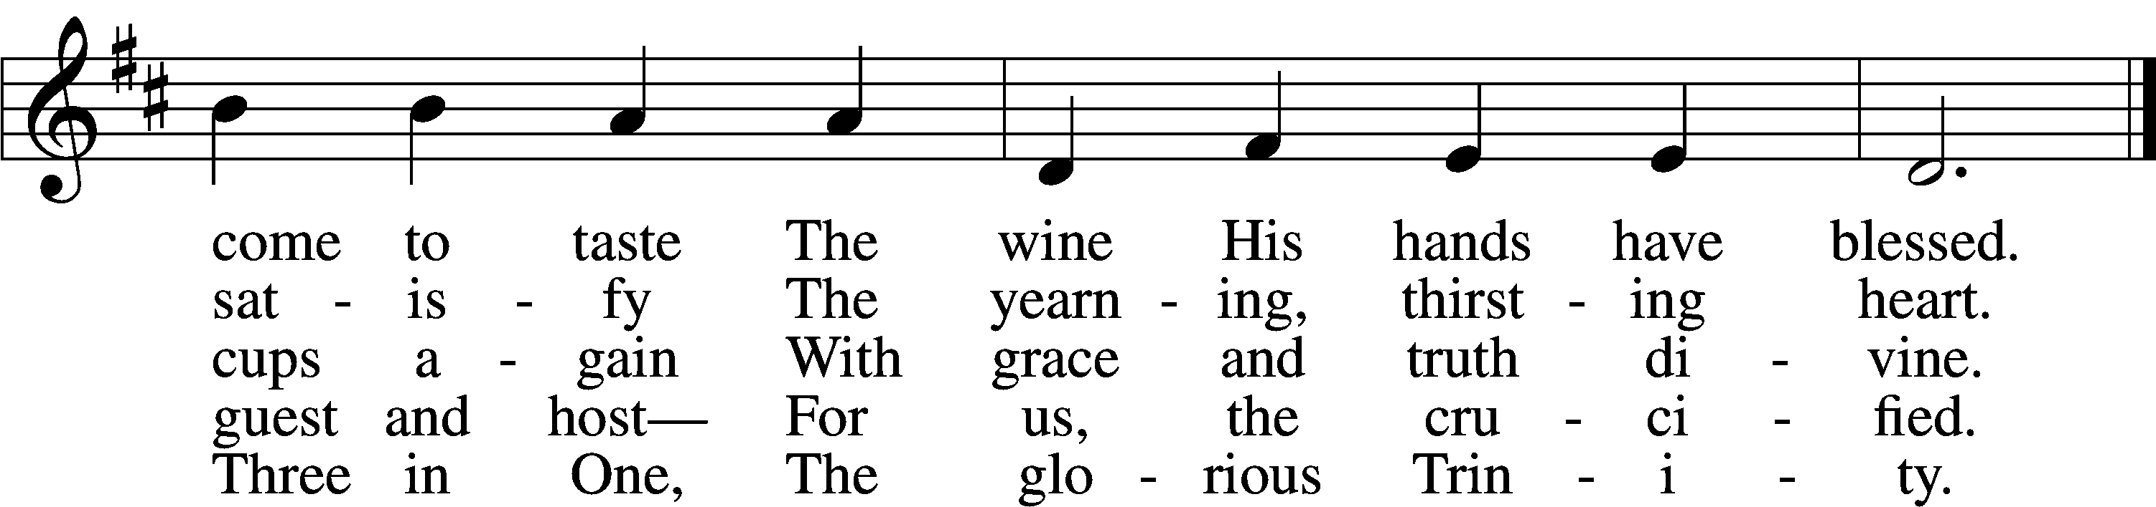

Text: Herman G. Stuempfle, Jr., 1923–2007  
Tune: Johann Balthasar König, 1691–1758; adapt. William H. Havergal, 1793–1870  
Text: © 1993 The Hymn Society, admin. Hope Publishing Co. Used by permission: LSB Hymn License no. 110000820  
Tune: Public domain

# + CONFESSION AND ABSOLUTION +

INVOCATION

P In the name of the Father and of the T Son and of the Holy Spirit.

C **Amen.**

EXHORTATION LSB 151

P If we say we have no sin, we deceive ourselves, and the truth is not in us.

C **But if we confess our sins, God, who is faithful and just, will forgive our sins and cleanse us from all unrighteousness.**

CONFESSION OF SINS LSB 151

P Let us then confess our sins to God our Father.

C **Most merciful God, we confess that we are by nature sinful and unclean. We have sinned against You in thought, word, and deed, by what we have done and by what we have left undone. We have not loved You with our whole heart; we have not loved our neighbors as ourselves. We justly deserve Your present and eternal punishment. For the sake of Your Son, Jesus Christ, have mercy on us. Forgive us, renew us, and lead us, so that we may delight in Your will and walk in Your ways to the glory of Your holy name. Amen.**

ABSOLUTION LSB 151

P Almighty God in His mercy has given His Son to die for you and for His sake forgives you all your sins. As a called and ordained servant of Christ, and by His authority, I therefore forgive you all your sins in the name of the Father and of the T Son and of the Holy Spirit.

C **Amen.**

# + SERVICE OF THE WORD +

INTROIT Psalm 36:5–9; antiphon: Song of Solomon 2:4

Pastor: [The Lord] brought me to the banqueting house,  
**Cong: and his banner over me was love.**  
Pastor: Your steadfast love, O Lord, extends to the heavens,  
**Cong: your faithfulness to the clouds.**  
Pastor: Your righteousness is like the mountains of God;  
**Cong: your judgments are like the great deep; man and beast you save, O Lord.**  
Pastor: How precious is your steadfast love, O God!  
**Cong: The children of mankind take refuge in the shadow of your wings.**  
Pastor: They feast on the abundance of your house,  
**Cong: and you give them drink from the river of your delights.**  
Pastor: For with you is the fountain of life;  
**Cong: in your light do we see light.**  
**Glory be to the Father and to the Son**  
 **and to the Holy Spirit;**  
**as it was in the beginning,**  
 **is now, and will be forever. Amen.**

KYRIE LSB 152

P In peace let us pray to the Lord.

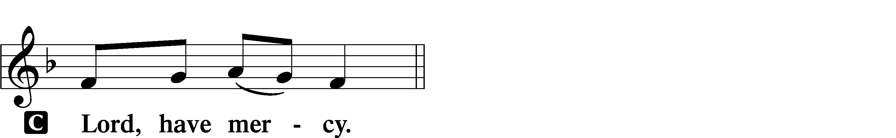

P For the peace from above and for our salvation let us pray to the Lord.

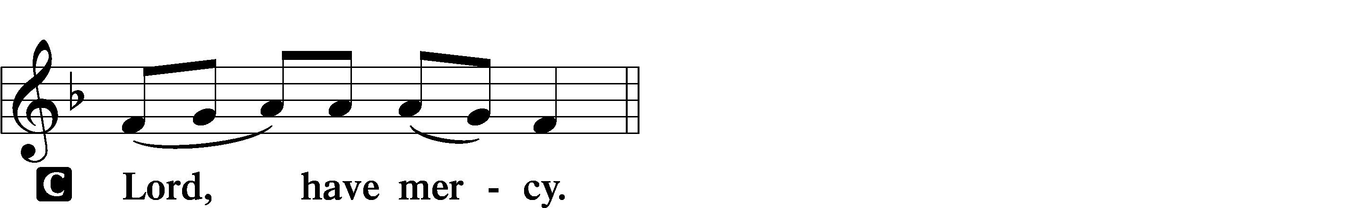

P For the peace of the whole world, for the well-being of the Church of God, and for the unity of all let us pray to the Lord.

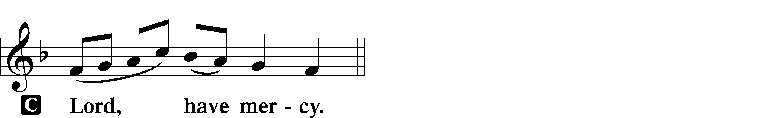

P For this holy house and for all who offer here their worship and praise let us pray to the Lord.

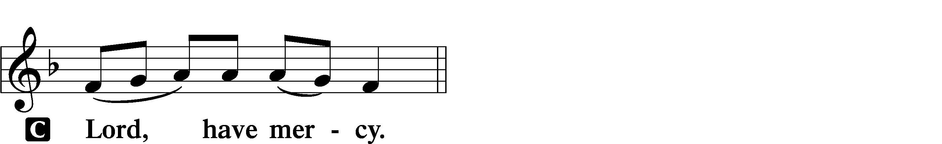

P Help, save, comfort, and defend us, gracious Lord.



THIS IS THE FEAST LSB 155

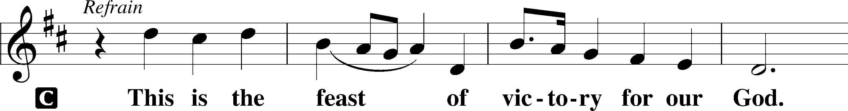

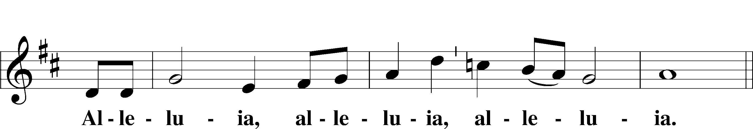

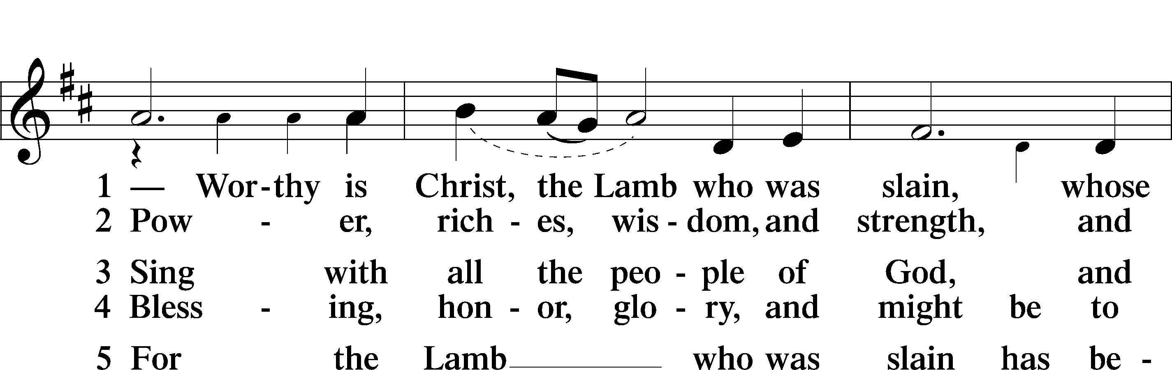

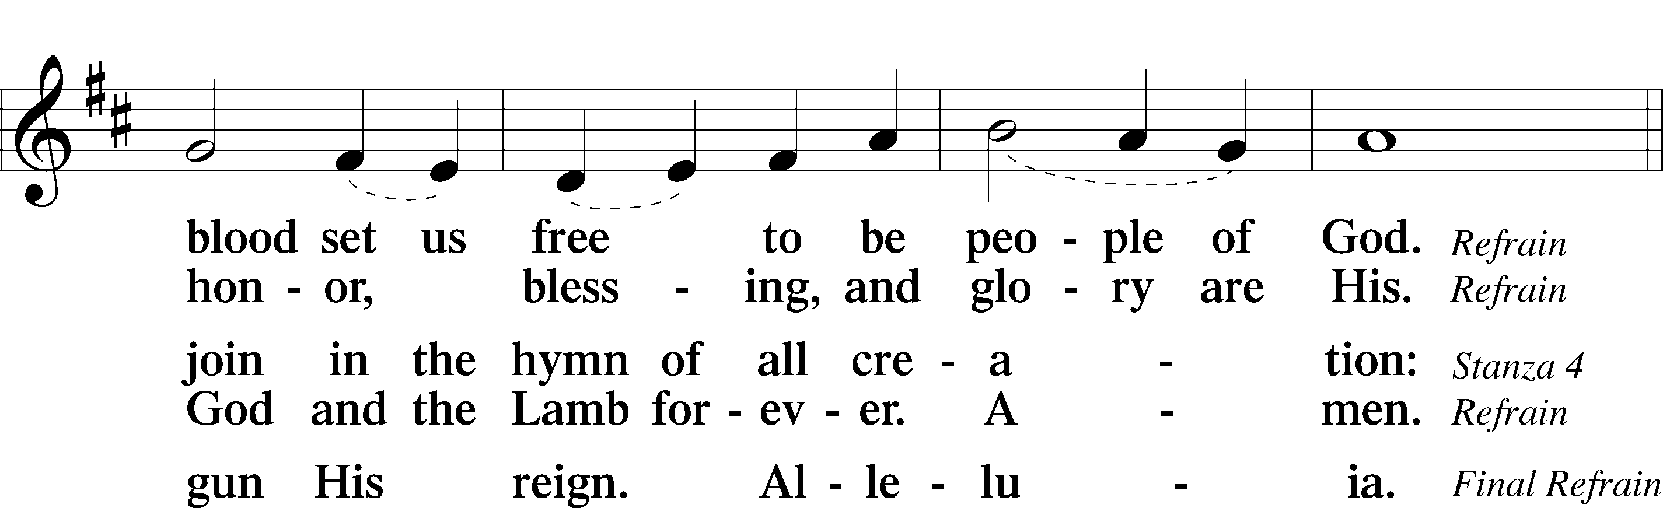

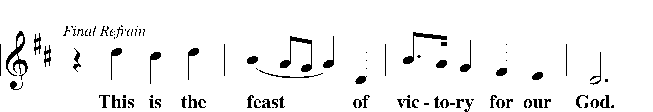

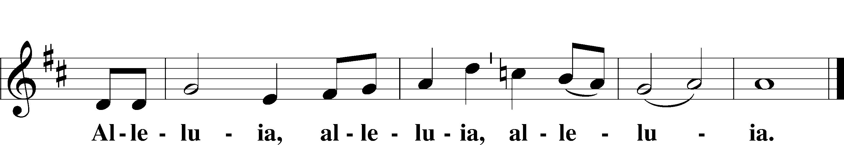

SALUTATION AND COLLECT OF THE DAY

P The Lord be with you.

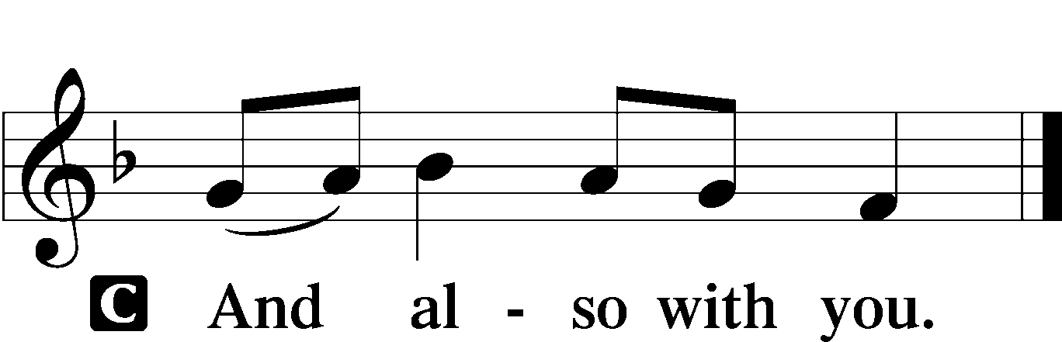

P Let us pray.

Almighty and everlasting God, who governs all things in heaven and on earth, mercifully hear the prayers of Your people and grant us Your peace through all our days; through Jesus Christ, Your Son, our Lord, who lives and reigns with You and the Holy Spirit, one God, now and forever.

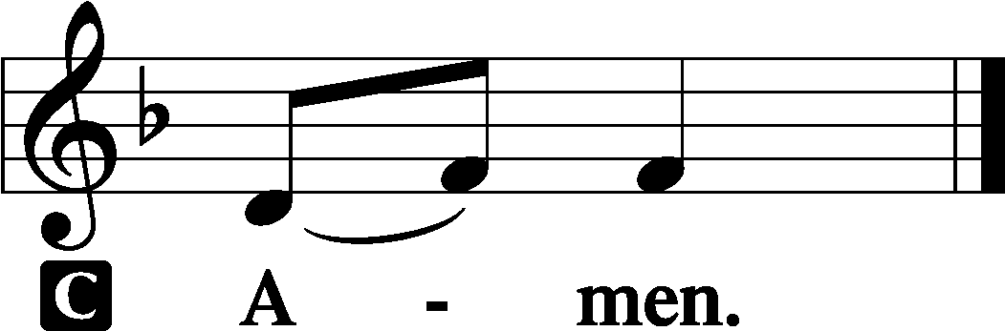

OLD TESTAMENT READING Isaiah 62:1–5

1For Zion’s sake I will not keep silent,  
 and for Jerusalem’s sake I will not be quiet,  
until her righteousness goes forth as brightness,  
 and her salvation as a burning torch.  
2The nations shall see your righteousness,  
 and all the kings your glory,  
and you shall be called by a new name  
 that the mouth of the Lord will give.  
3You shall be a crown of beauty in the hand of the Lord,  
 and a royal diadem in the hand of your God.  
4You shall no more be termed Forsaken,  
 and your land shall no more be termed Desolate,  
but you shall be called My Delight Is in Her,  
 and your land Married;  
for the Lord delights in you,  
 and your land shall be married.  
5For as a young man marries a young woman,  
 so shall your sons marry you,  
and as the bridegroom rejoices over the bride,  
 so shall your God rejoice over you.

P This is the Word of the Lord.

C **Thanks be to God.**

EPISTLE 1 Corinthians 12:1–11

1Now concerning spiritual gifts, brothers, I do not want you to be uninformed. 2You know that when you were pagans you were led astray to mute idols, however you were led. 3Therefore I want you to understand that no one speaking in the Spirit of God ever says “Jesus is accursed!” and no one can say “Jesus is Lord” except in the Holy Spirit.

4Now there are varieties of gifts, but the same Spirit; 5and there are varieties of service, but the same Lord; 6and there are varieties of activities, but it is the same God who empowers them all in everyone. 7To each is given the manifestation of the Spirit for the common good. 8To one is given through the Spirit the utterance of wisdom, and to another the utterance of knowledge according to the same Spirit, 9to another faith by the same Spirit, to another gifts of healing by the one Spirit, 10to another the working of miracles, to another prophecy, to another the ability to distinguish between spirits, to another various kinds of tongues, to another the interpretation of tongues. 11All these are empowered by one and the same Spirit, who apportions to each one individually as he wills.

P This is the Word of the Lord.

C **Thanks be to God.**

ALLELUIA AND VERSE LSB 156

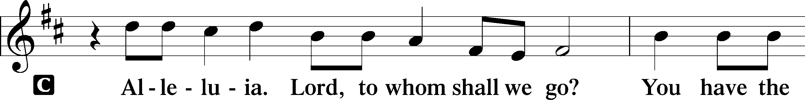

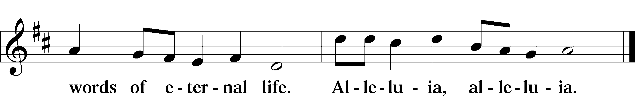

GOSPEL John 2:1–11

P The Holy Gospel according to St. John, the second chapter.

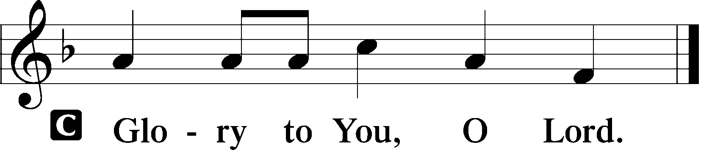

1On the third day there was a wedding at Cana in Galilee, and the mother of Jesus was there. 2Jesus also was invited to the wedding with his disciples. 3When the wine ran out, the mother of Jesus said to him, “They have no wine.” 4And Jesus said to her, “Woman, what does this have to do with me? My hour has not yet come.” 5His mother said to the servants, “Do whatever he tells you.”

6Now there were six stone water jars there for the Jewish rites of purification, each holding twenty or thirty gallons. 7Jesus said to the servants, “Fill the jars with water.” And they filled them up to the brim. 8And he said to them, “Now draw some out and take it to the master of the feast.” So they took it. 9When the master of the feast tasted the water now become wine, and did not know where it came from (though the servants who had drawn the water knew), the master of the feast called the bridegroom 10and said to him, “Everyone serves the good wine first, and when people have drunk freely, then the poor wine. But you have kept the good wine until now.” 11This, the first of his signs, Jesus did at Cana in Galilee, and manifested his glory. And his disciples believed in him.

P This is the Gospel of the Lord.

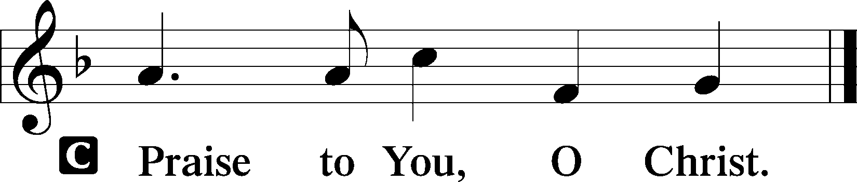

402 THE ONLY SON FROM HEAVEN

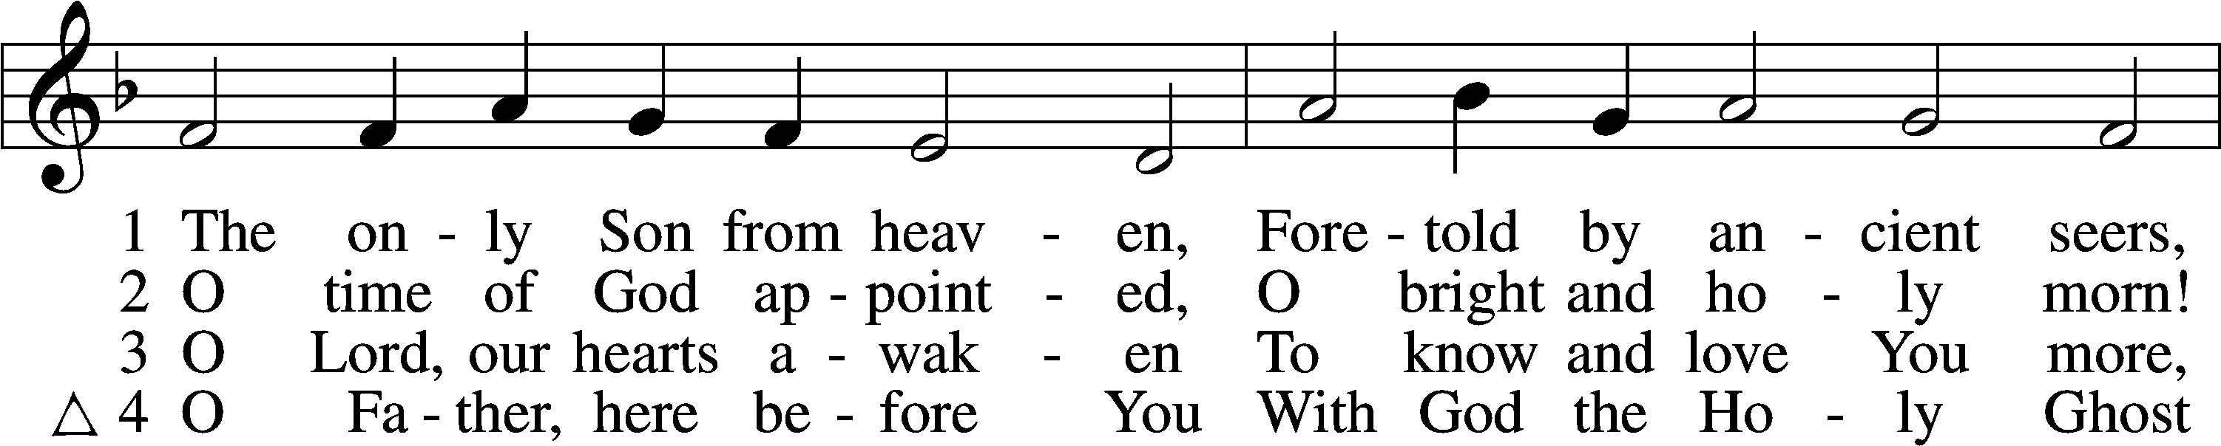

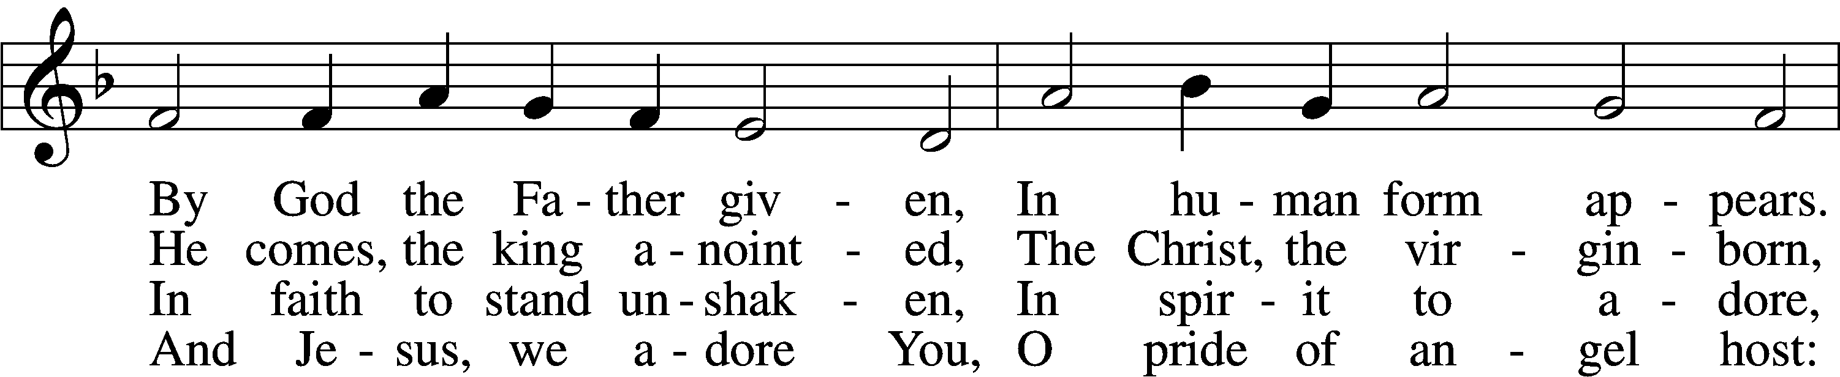

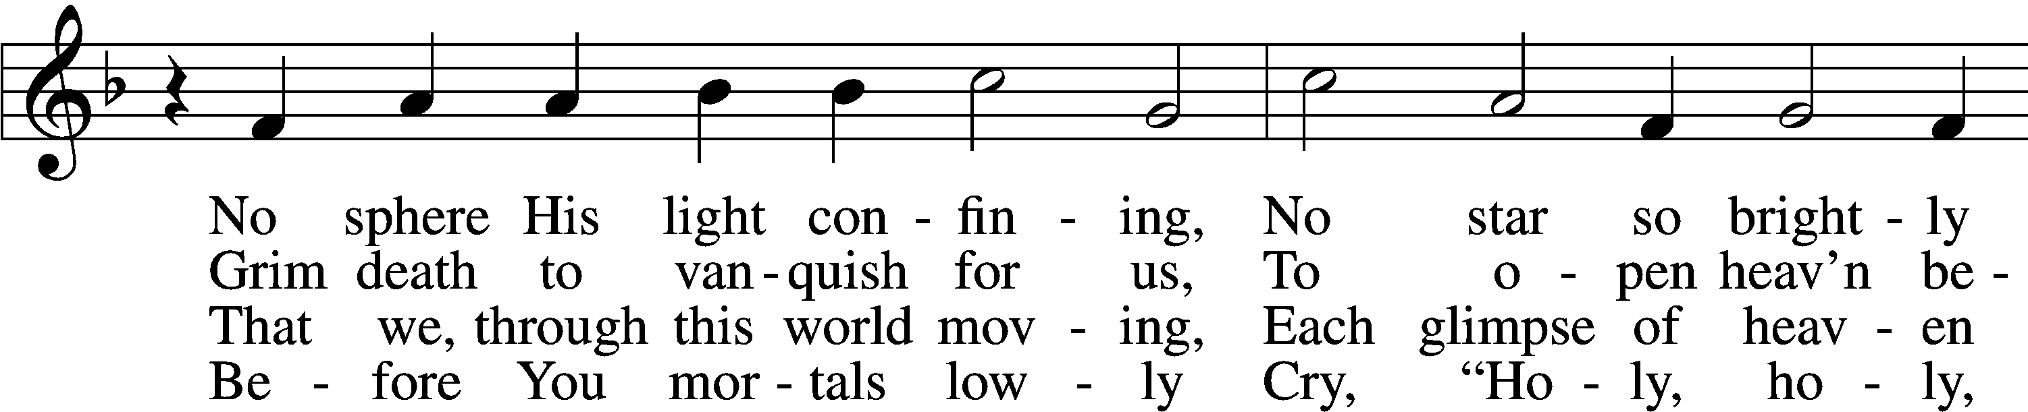

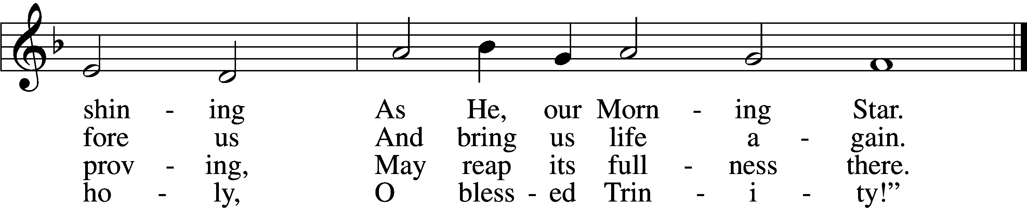

Text (sts. 1–3): Elisabeth Cruciger, c. 1500–1535; (sts. 1–3): tr. Arthur T. Russell, 1806–74, alt.; (st. 4): Lutheran Book of Worship, 1978  
Tune: Eyn Enchiridion oder Handbüchlein, 1524, Erfurt  
Text and tune: Public domain

SERMON

APOSTLES’ CREED

C **I believe in God, the Father Almighty,**

**maker of heaven and earth.**

**And in Jesus Christ, His only Son, our Lord,**

**who was conceived by the Holy Spirit,**

**born of the virgin Mary,**

**suffered under Pontius Pilate,**

**was crucified, died and was buried.**

**He descended into hell.**

**The third day He rose again from the dead.**

**He ascended into heaven**

**and sits at the right hand of God the Father Almighty.**

**From thence He will come to judge the living and the dead.**

**I believe in the Holy Spirit,**

**the holy Christian Church,**

**the communion of saints,**

**the forgiveness of sins,**

**the resurrection of the body,**

**and the life** T **everlasting. Amen.**

PRAYER OF THE CHURCH

956 CREATE IN ME

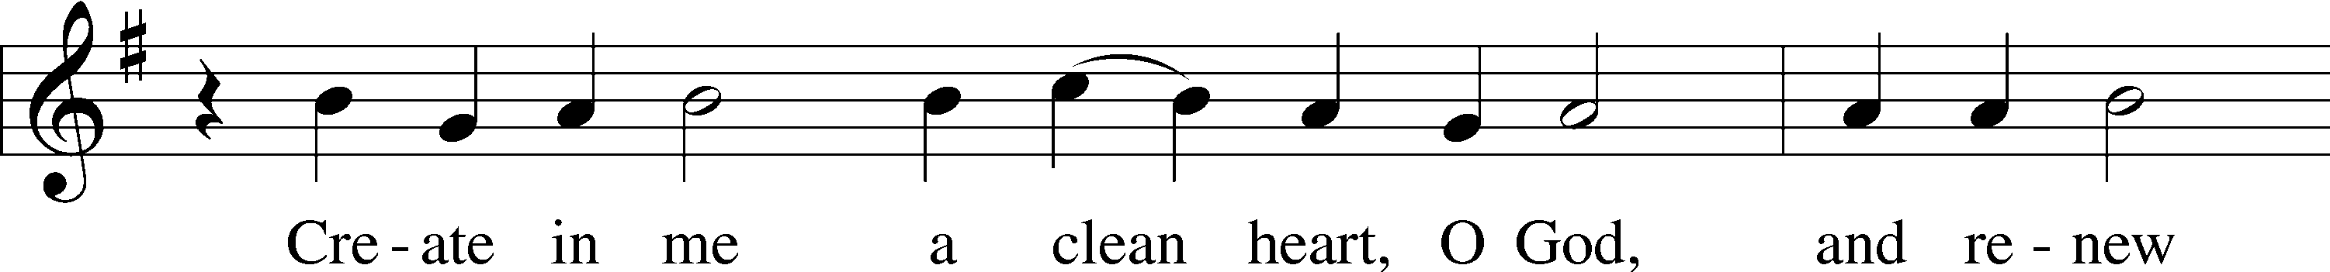

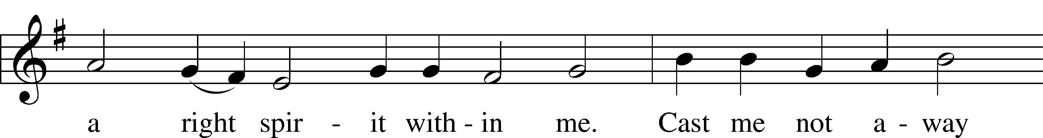

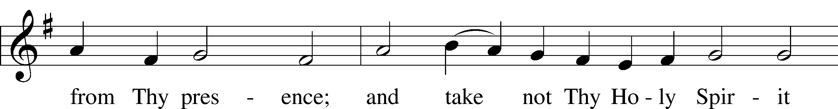

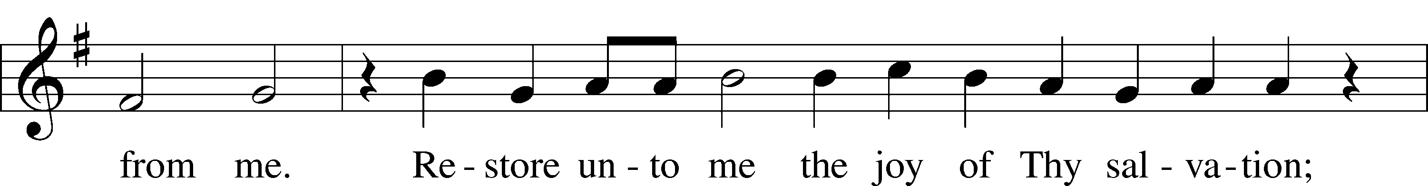

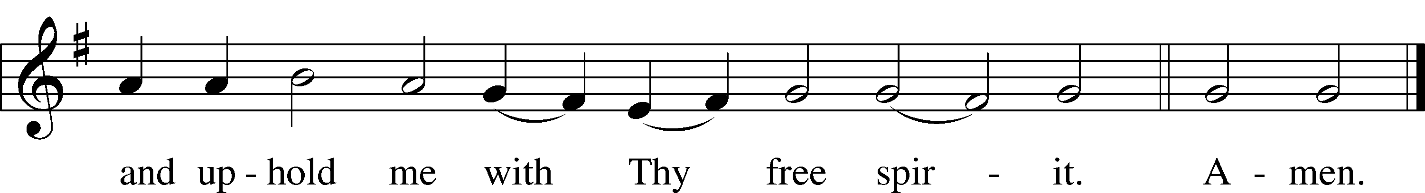

Text: Psalm 51:10–12  
Tune: Johann Georg Winer, 1583–1651, adapt.  
Text and tune: Public domain

# + SERVICE OF THE SACRAMENT +

PREFACE LSB 160

P The Lord be with you.



P Lift up your hearts.



P Let us give thanks to the Lord our God.

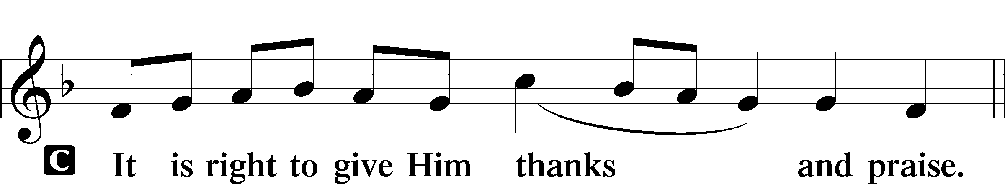

PROPER PREFACE (ABBREVIATED) LSB 161

P It is truly good, right, and salutary . . . evermore praising You and saying:

SANCTUS LSB 161

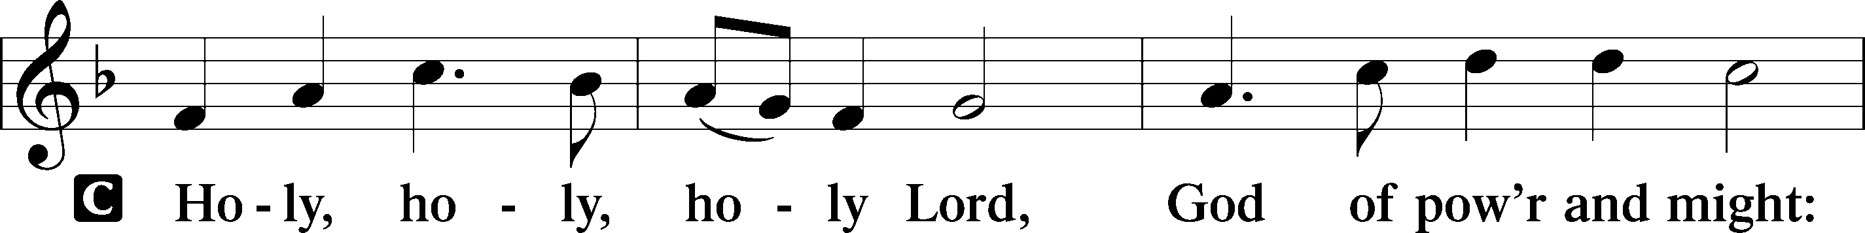

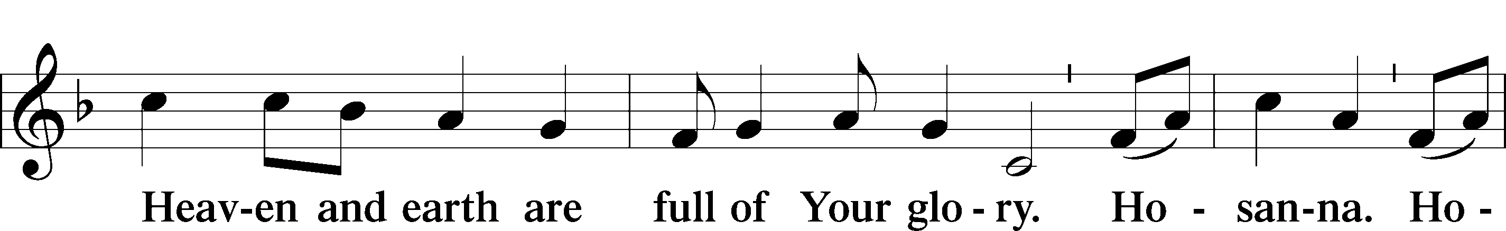

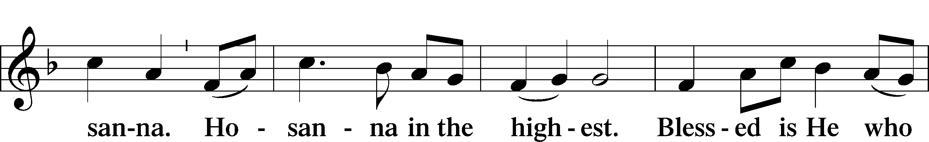

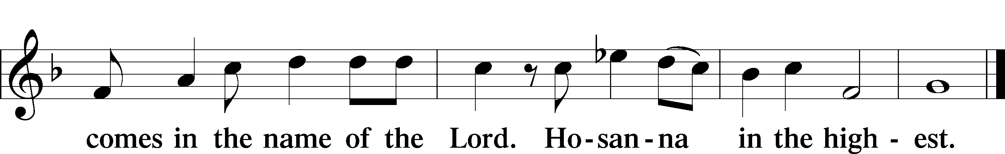

LORD’S PRAYER LSB 162

P Lord, remember us in Your kingdom and teach us to pray:

C **Our Father who art in heaven,**

**hallowed be Thy name,**

**Thy kingdom come,**

**Thy will be done on earth**

**as it is in heaven;**

**give us this day our daily bread;**

**and forgive us our trespasses**

**as we forgive those**

**who trespass against us;**

**and lead us not into temptation,**

**but deliver us from evil.**

**For Thine is the kingdom**

**and the power and the glory**

**forever and ever. Amen.**

THE WORDS OF OUR LORD

P Our Lord Jesus Christ, on the night when He was betrayed, took bread, and when He had given thanks, He broke it and gave it to the disciples and said: “Take, eat; this is My T body, which is given for you. This do in remembrance of Me.”

In the same way also He took the cup after supper, and when He had given thanks, He gave it to them, saying: “Drink of it, all of you; this cup is the new testament in My T blood, which is shed for you for the forgiveness of sins. This do, as often as you drink it, in remembrance of Me.”

PAX DOMINI LSB 163

P The peace of the Lord be with you always.



AGNUS DEI LSB 163

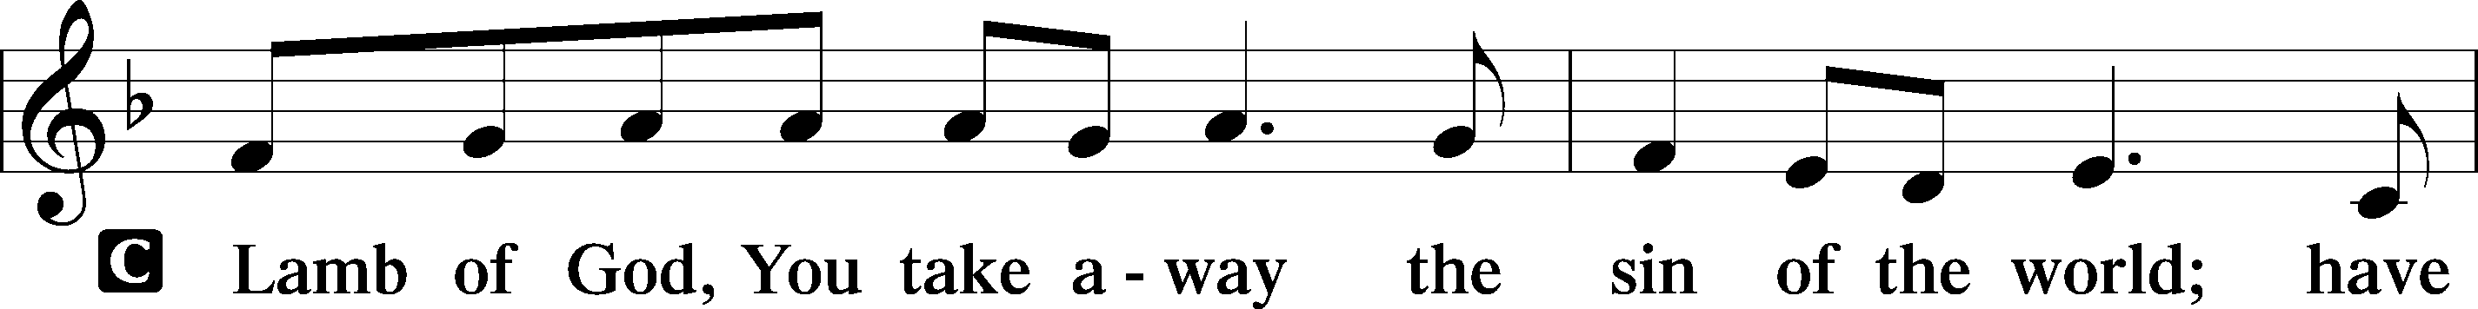

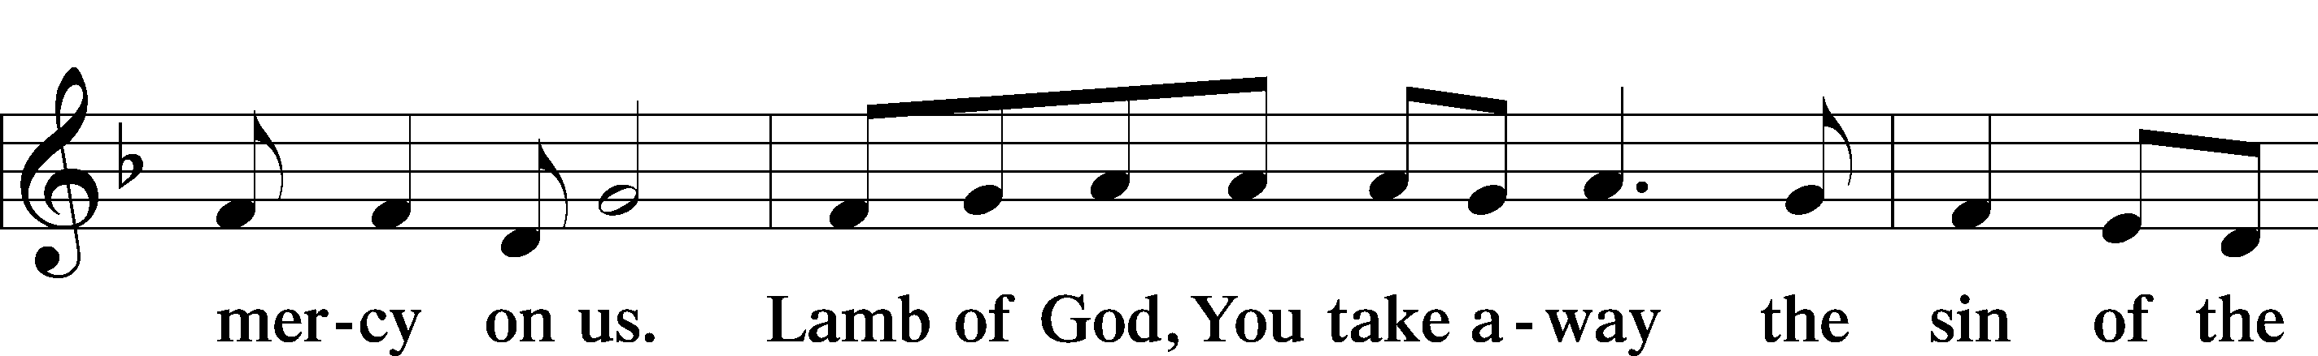

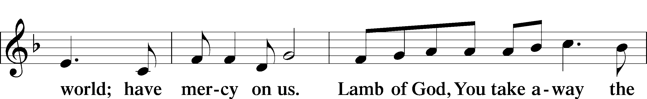

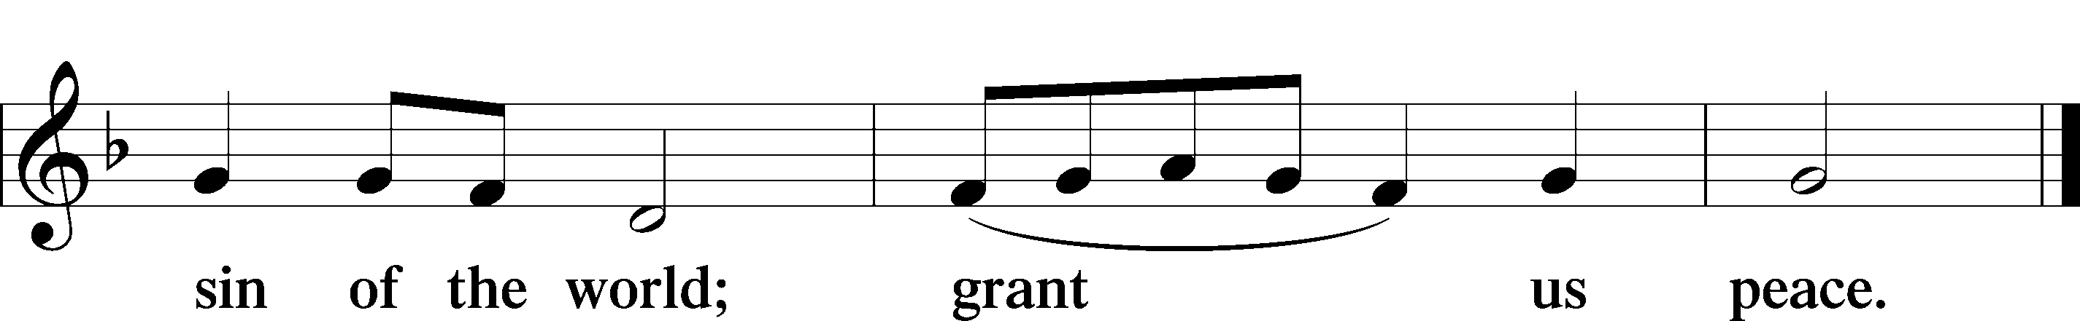

DISTRIBUTION

644 THE CHURCH’S ONE FOUNDATION

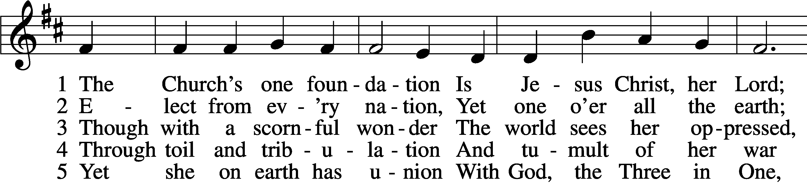

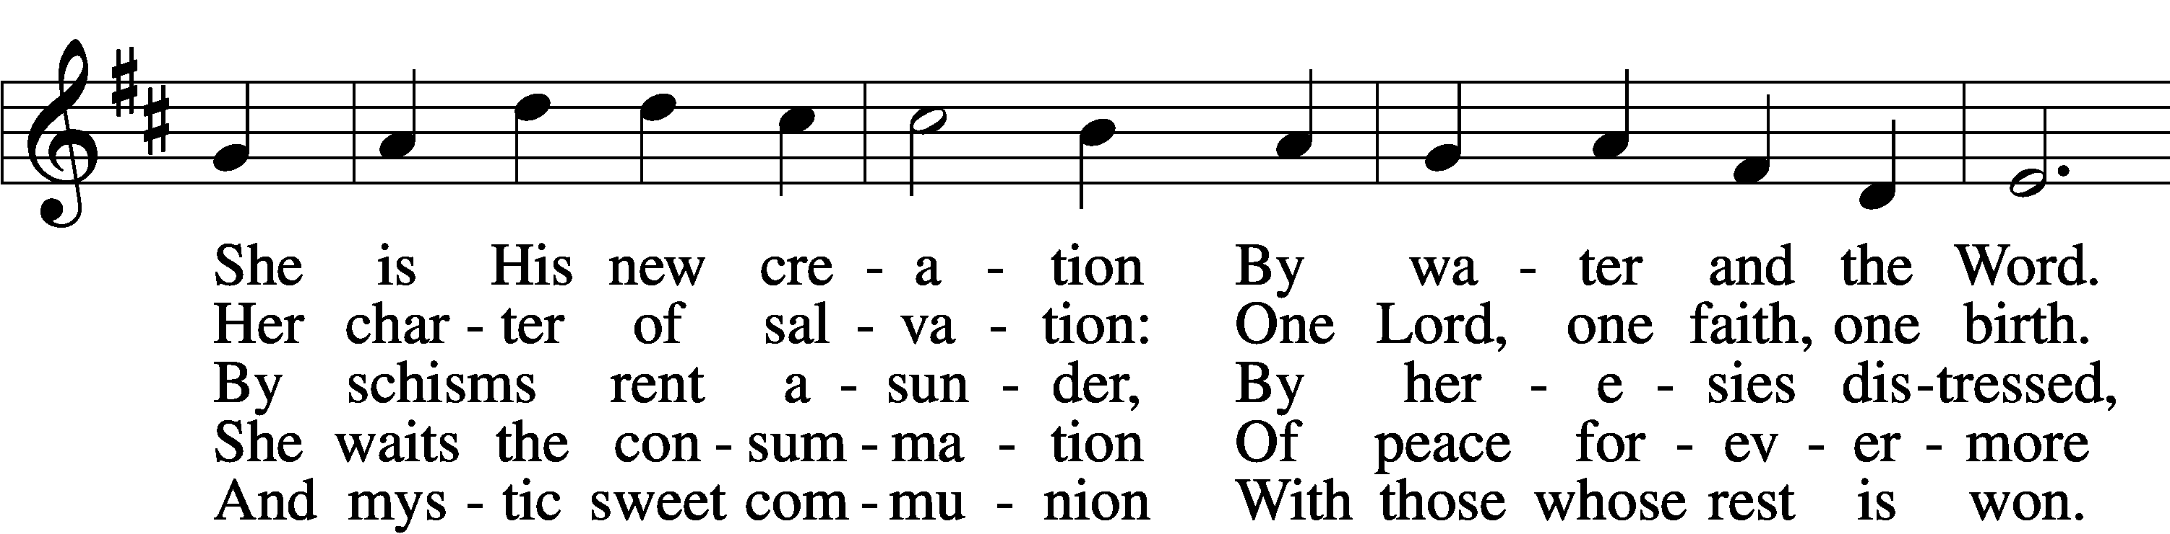

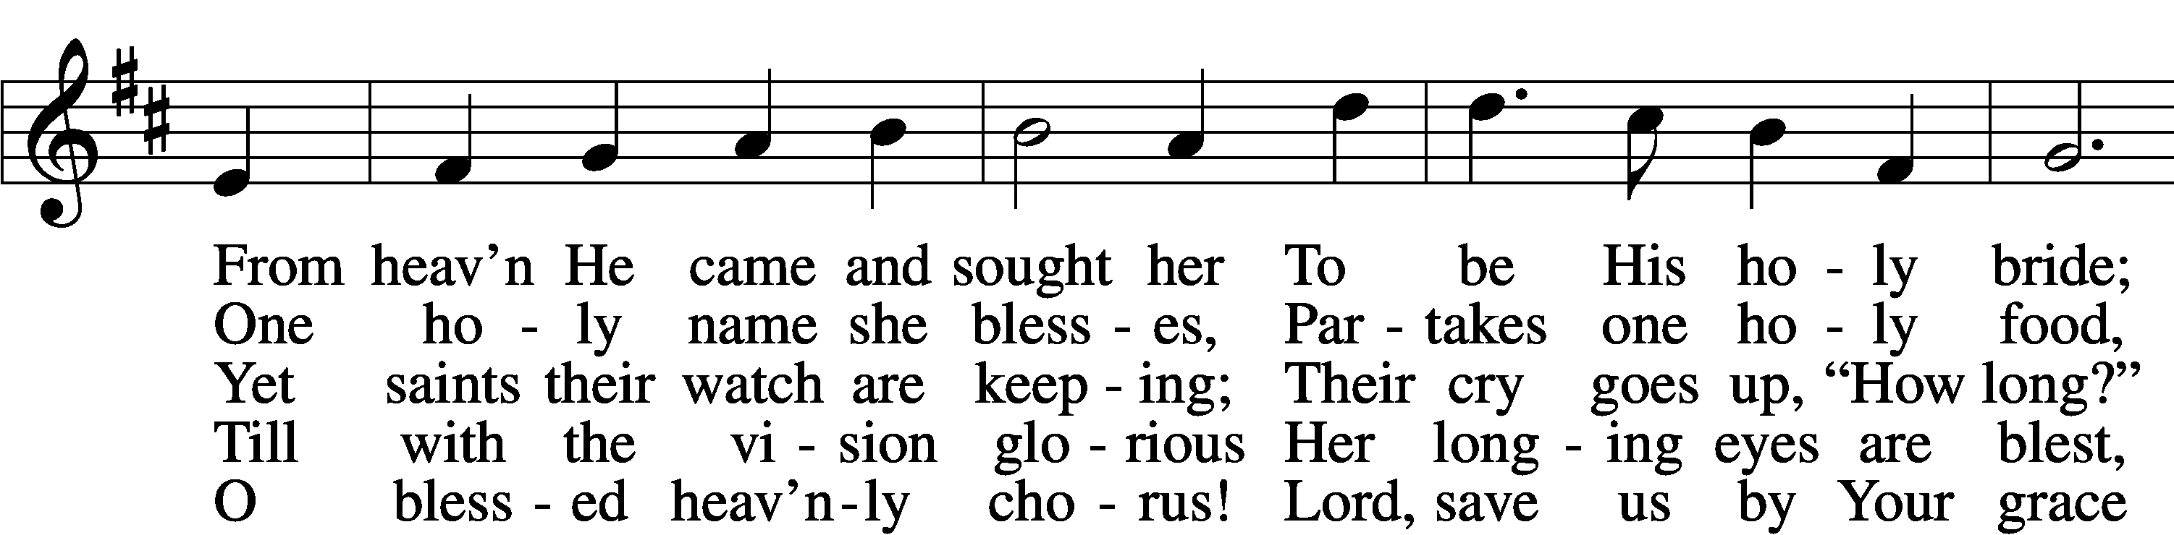

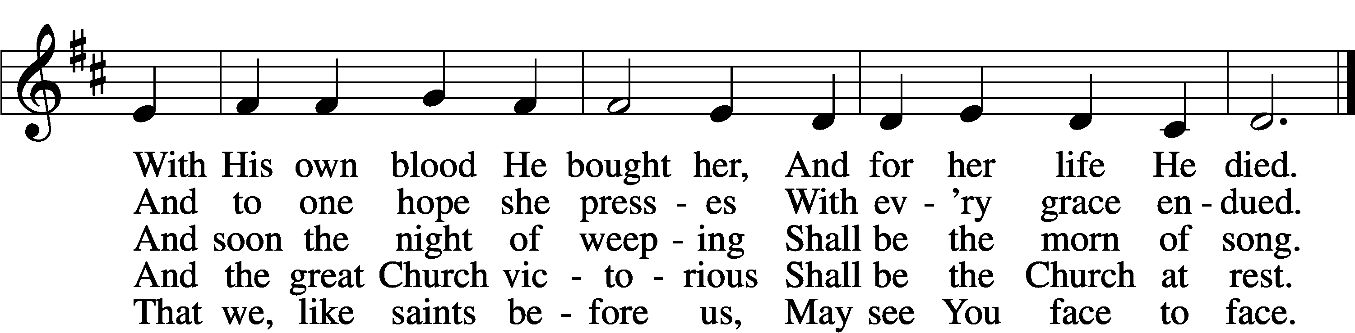

Text: Samuel J. Stone, 1839–1900, alt.  
Tune: Samuel S. Wesley, 1810–76  
Text and tune: Public domain

637 DRAW NEAR AND TAKE THE BODY OF THE LORD

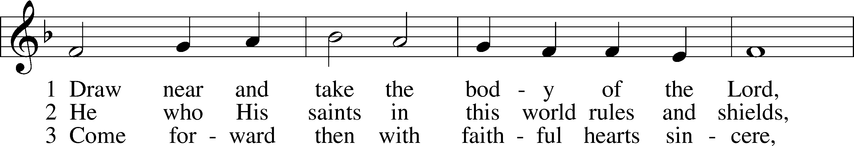

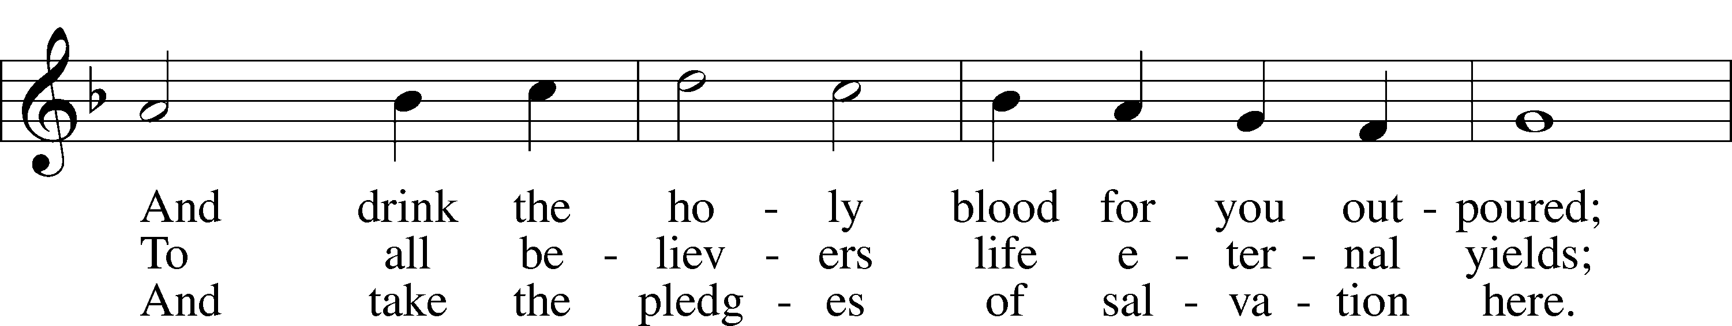

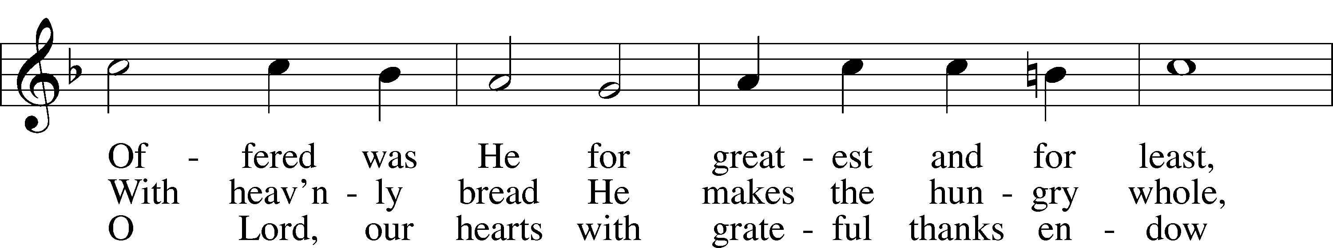

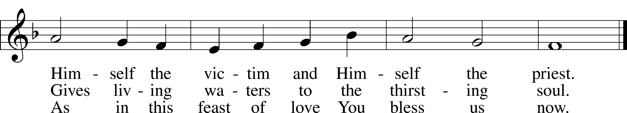

Text: Latin, 7th cent.; tr. John Mason Neale, 1818–66, alt.  
Tune: Trente quatre Pseaumes de David, 1551, Geneva, ed. Louis Bourgeois  
Text and tune: Public domain

693 O HOLY SPIRIT, GRANT US GRACE

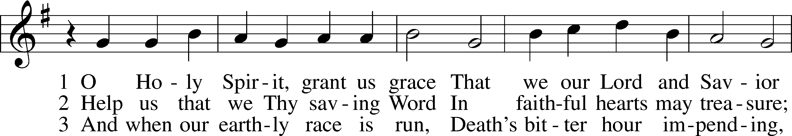

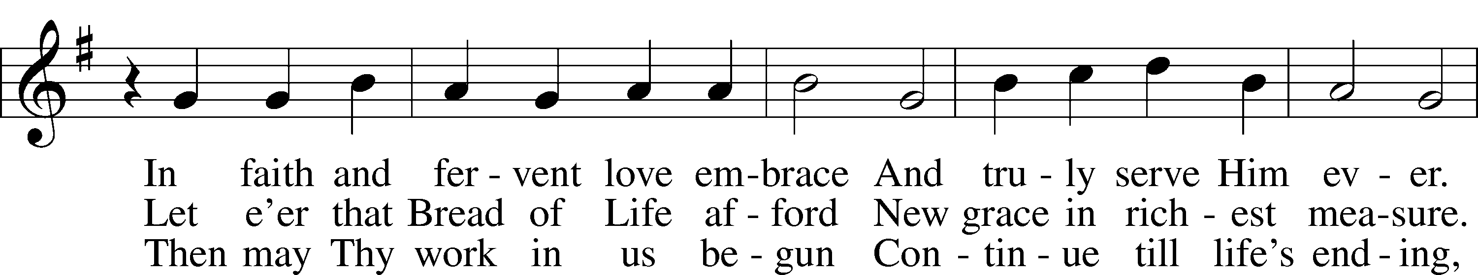

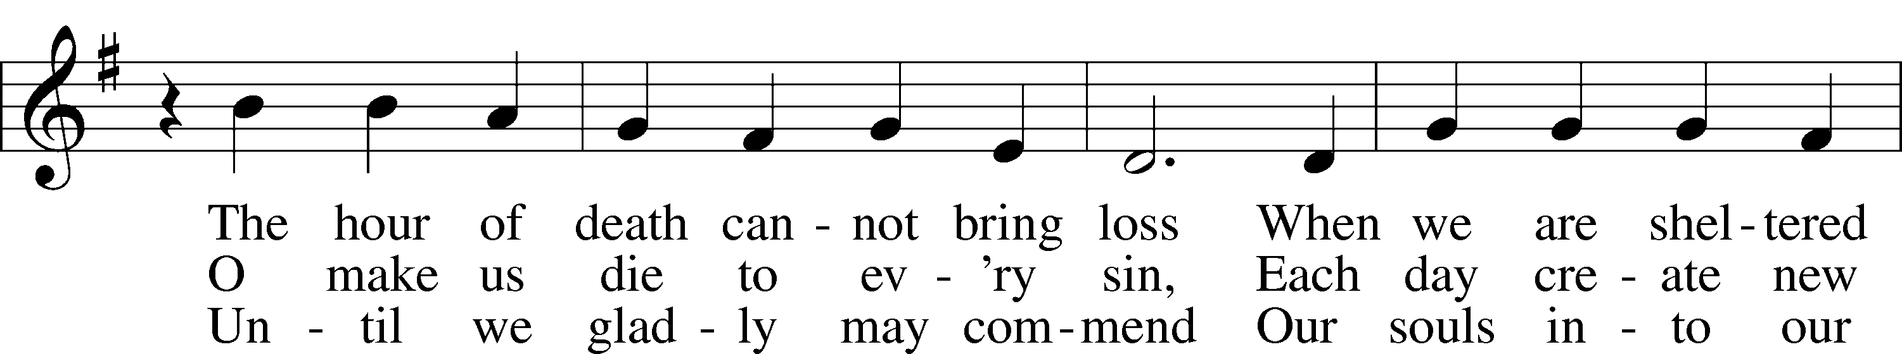

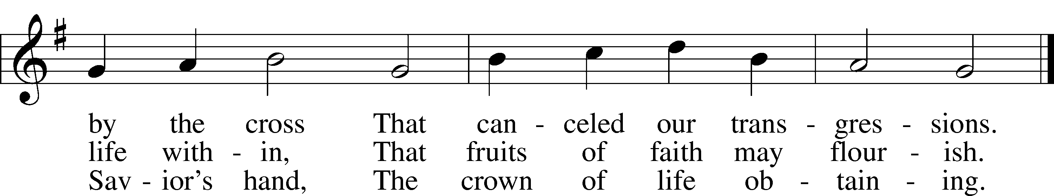

Text: Bartholomäus Ringwaldt, 1532–99; tr. Oluf H. Smeby, 1851–1929, alt.  
Tune: Geistliche Lieder auffs new gebessert, 1535, Wittenberg, ed. Joseph Klug  
Text and tune: Public domain

398 HAIL TO THE LORD’S ANOINTED

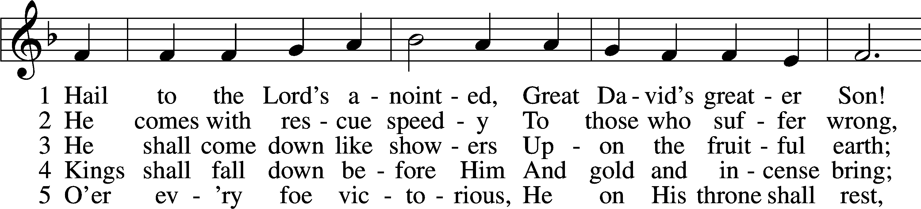

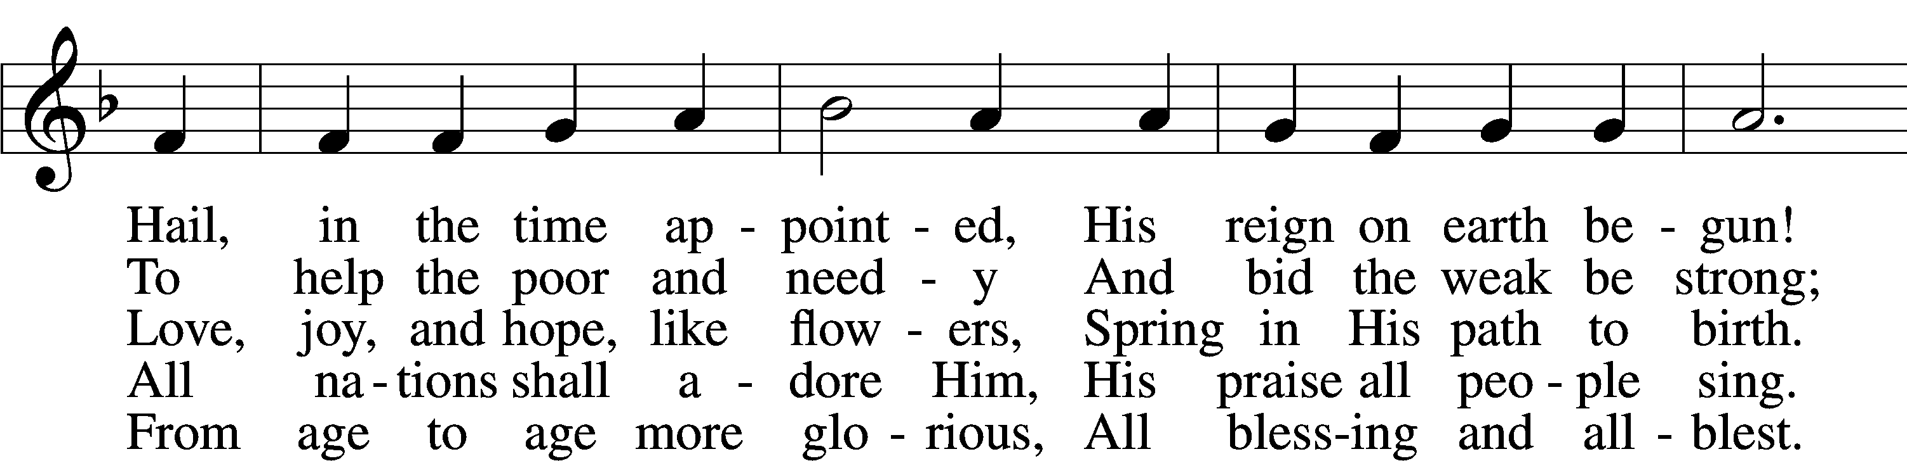

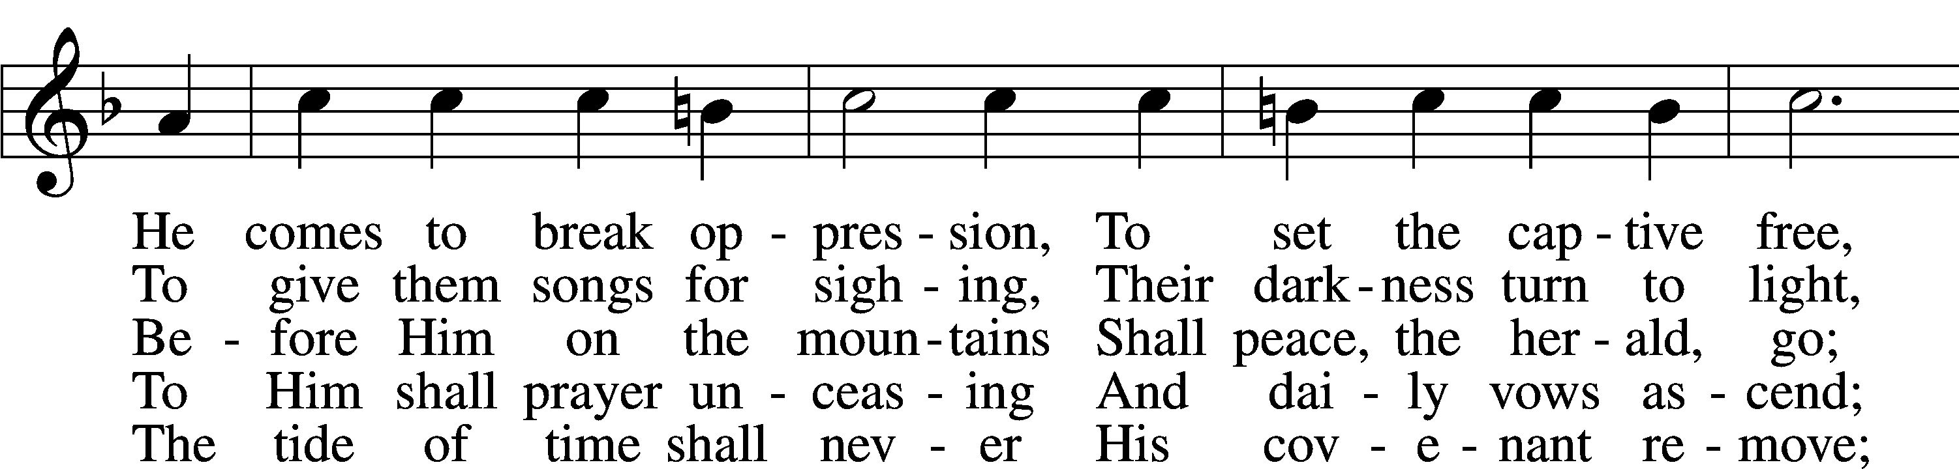

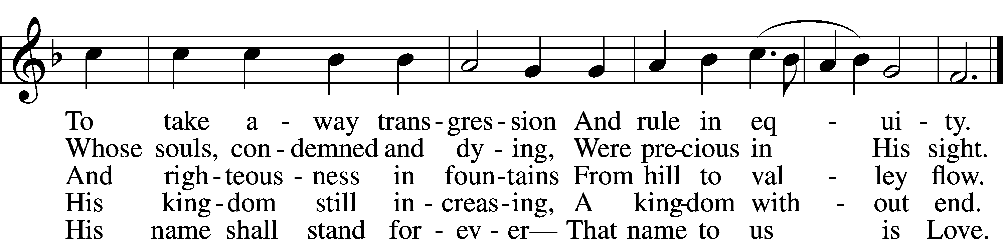

Text: James Montgomery, 1771–1854, alt.  
Tune: Leonhart Schröter, c. 1532–c. 1601  
Text and tune: Public domain

THANK THE LORD LSB 164

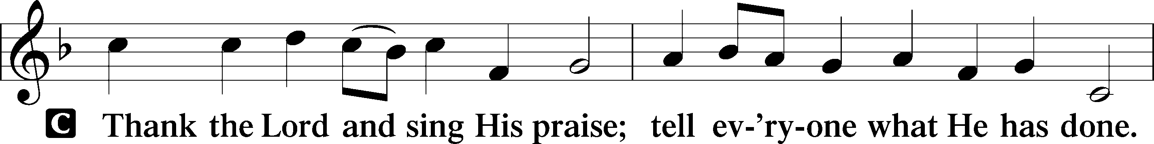

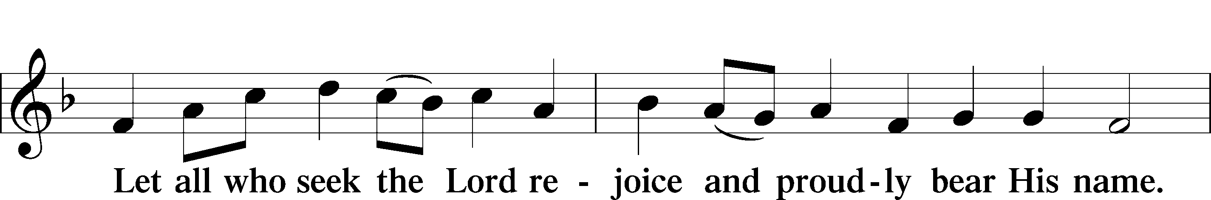

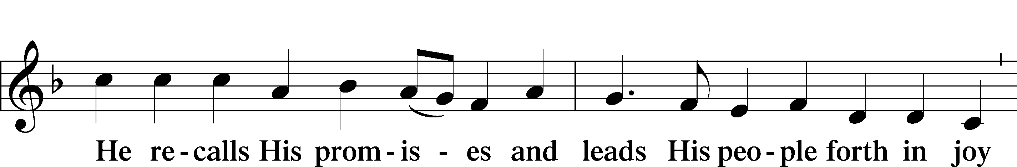

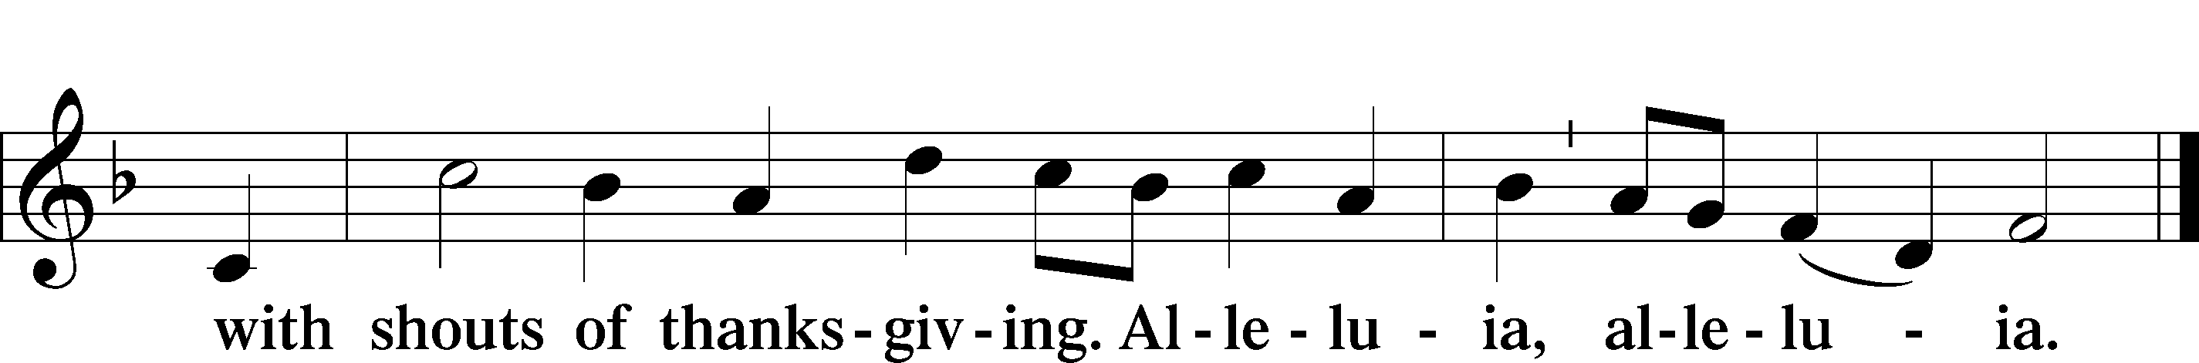

POST COMMUNION COLLECT

BENEDICTION LSB 166

P The Lord bless you and keep you.

The Lord make His face shine on you and be gracious to you.

The Lord look upon you with favor and T give you peace.



394 SONGS OF THANKFULNESS AND PRAISE

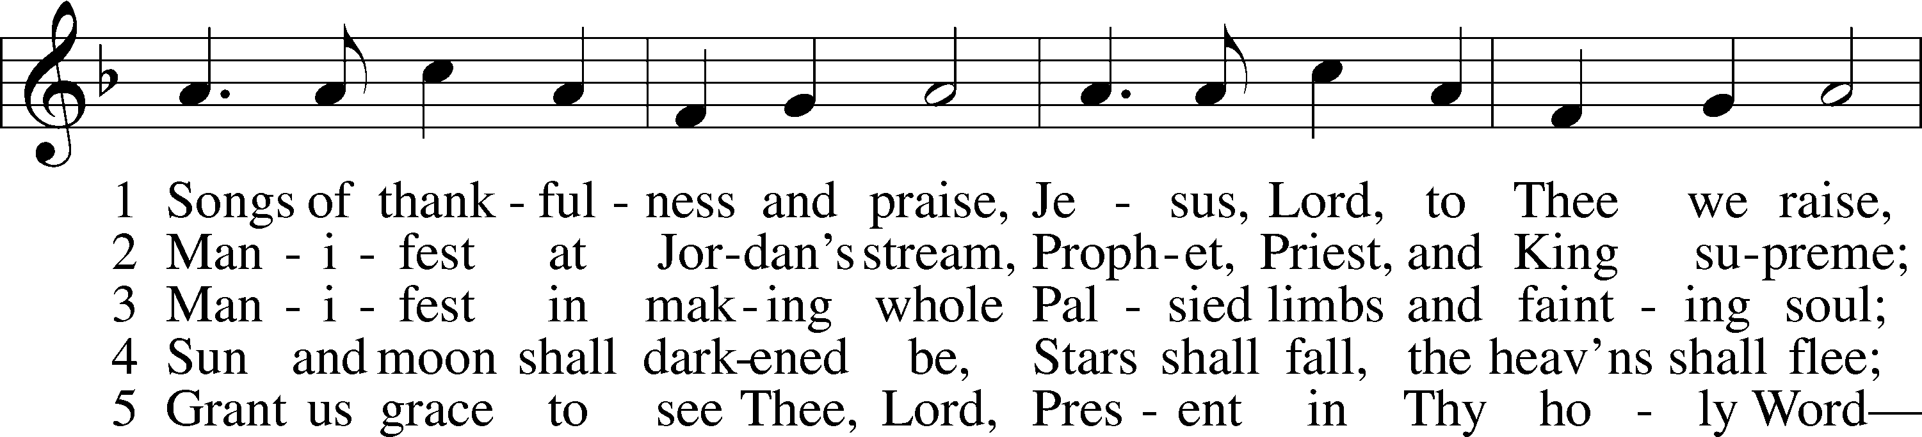

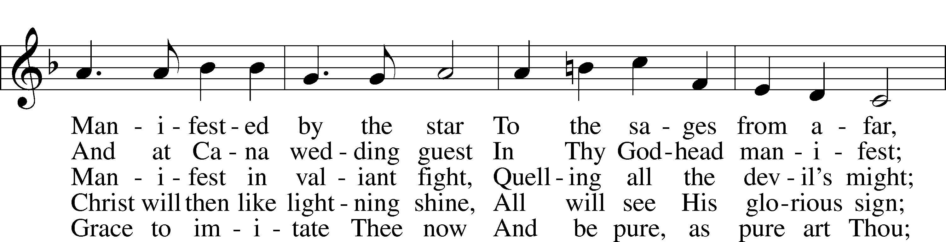

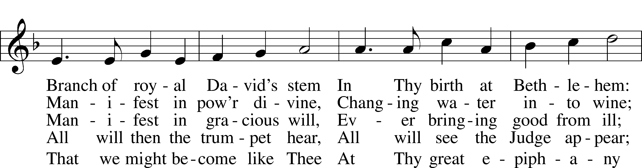

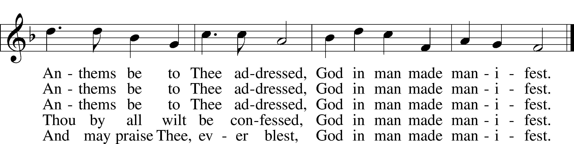

Text: Christopher Wordsworth, 1807–85, alt.  
Tune: George J. Elvey, 1816–93  
Text and tune: Public domain

ACKNOWLEDGMENTS

Unless otherwise indicated, Scripture quotations are from the ESV® Bible (The Holy Bible, English Standard Version®), copyright © 2001 by Crossway, a publishing ministry of Good News Publishers. Used by permission. All rights reserved.

Created by Lutheran Service Builder © 2025 Concordia Publishing House.



**Rev. Patrick Poock**

**Organist: Lillian Boettcher**

**THIS WEEK’S ACTIVITIES AT FAITH:**

**Happy Birthday**

**Renee Cole 19th**

**Aaron Boettcher 20th**

**Lisa Boettcher 21st**

**Francis Bedana 24th**

**Elena McAnally 24th**

**Gene Hemingway 25th**

**Happy Anniversary**

**David & Susan Barber 24th (55 yrs)**

**James & Sheila smith 25th (51 yrs)**

**THIS WEEK’S ACTIVITIES AT FAITH:**

**Sunday, January 19th**

**8:00 am Divine Service**

**9:15 am Sunday School/Bible Class**

10:30 am Divine Service

11:30 am Coffee Bites

**Tuesday, January 21st**

9:00 am Men’s Group Breakfast at Popi’s

**Wednesday, January 22nd**

9:00 am Women of Faith

5:00 pm Divine Service

**NO** Bible Study 3:30 or 6:30

**Looking Ahead**

Sunday, January 26th

8:00 am Divine Service

9:15 am Bible Class/Sunday School

10:30 am Divine Service

11:30 am Coffee Bites

Wednesday, January 29th

5:00 pm Divine Service

3:30 & 6:30 pm Bible Study